Graphing in Excel
1.In Excel, type Trial 1 in B1, Trial 2 in C1 and Trial 3 in D1
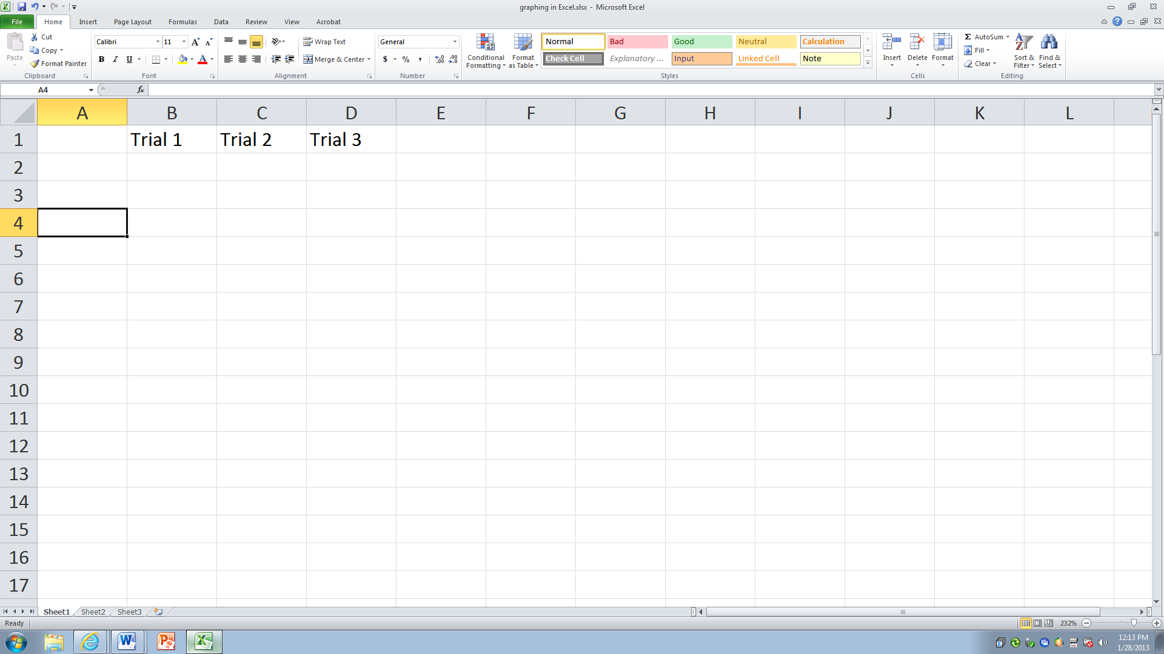
2.Next, you will enter the actual categories. Ex: A2 type Rock Salt, A3 type Cat Litter, A4 type Sand.
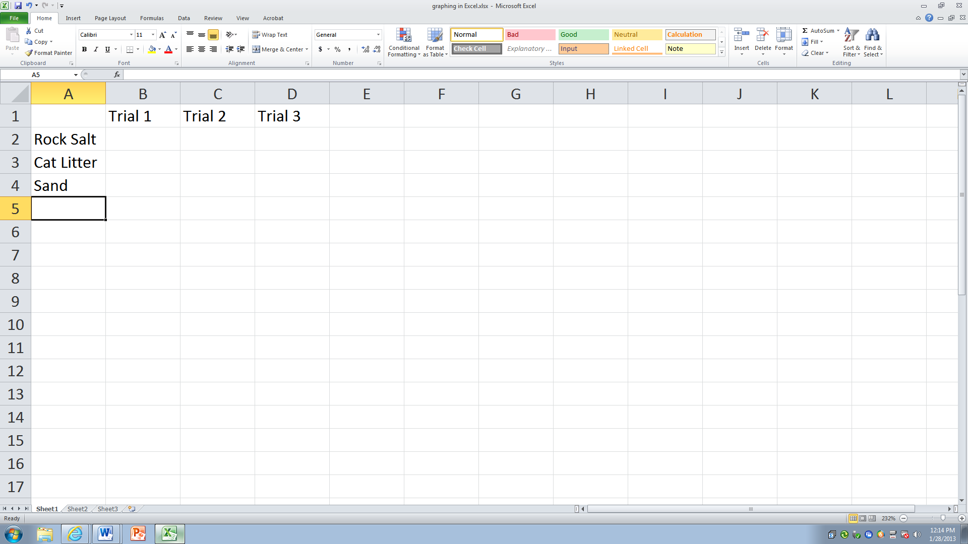
3.Now you will enter your data (numbers). Type those in as follows:
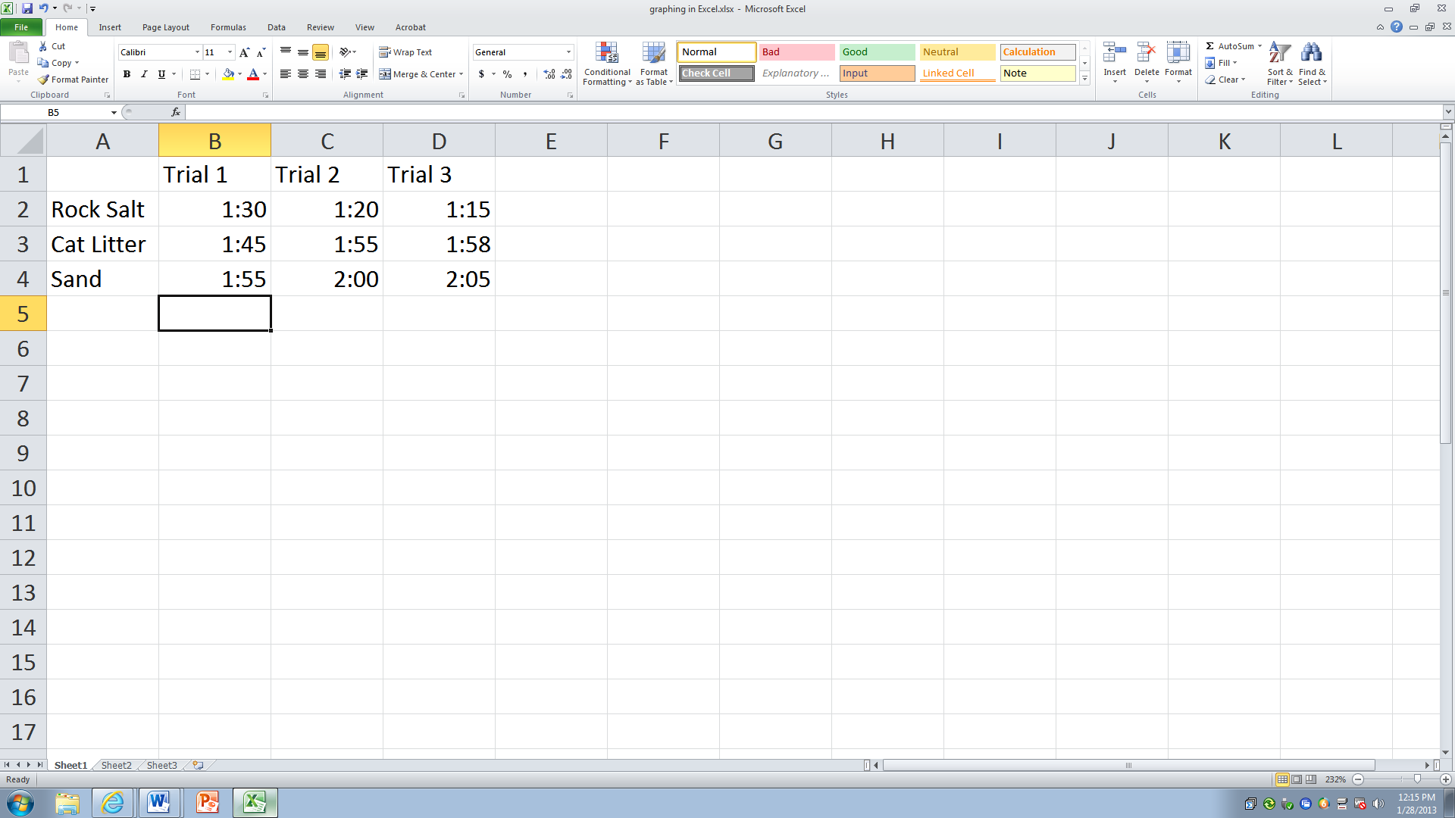

4.Now you are ready to create a graph.

5. To create a bar graph, highlight cells A1 through D4 (see example).
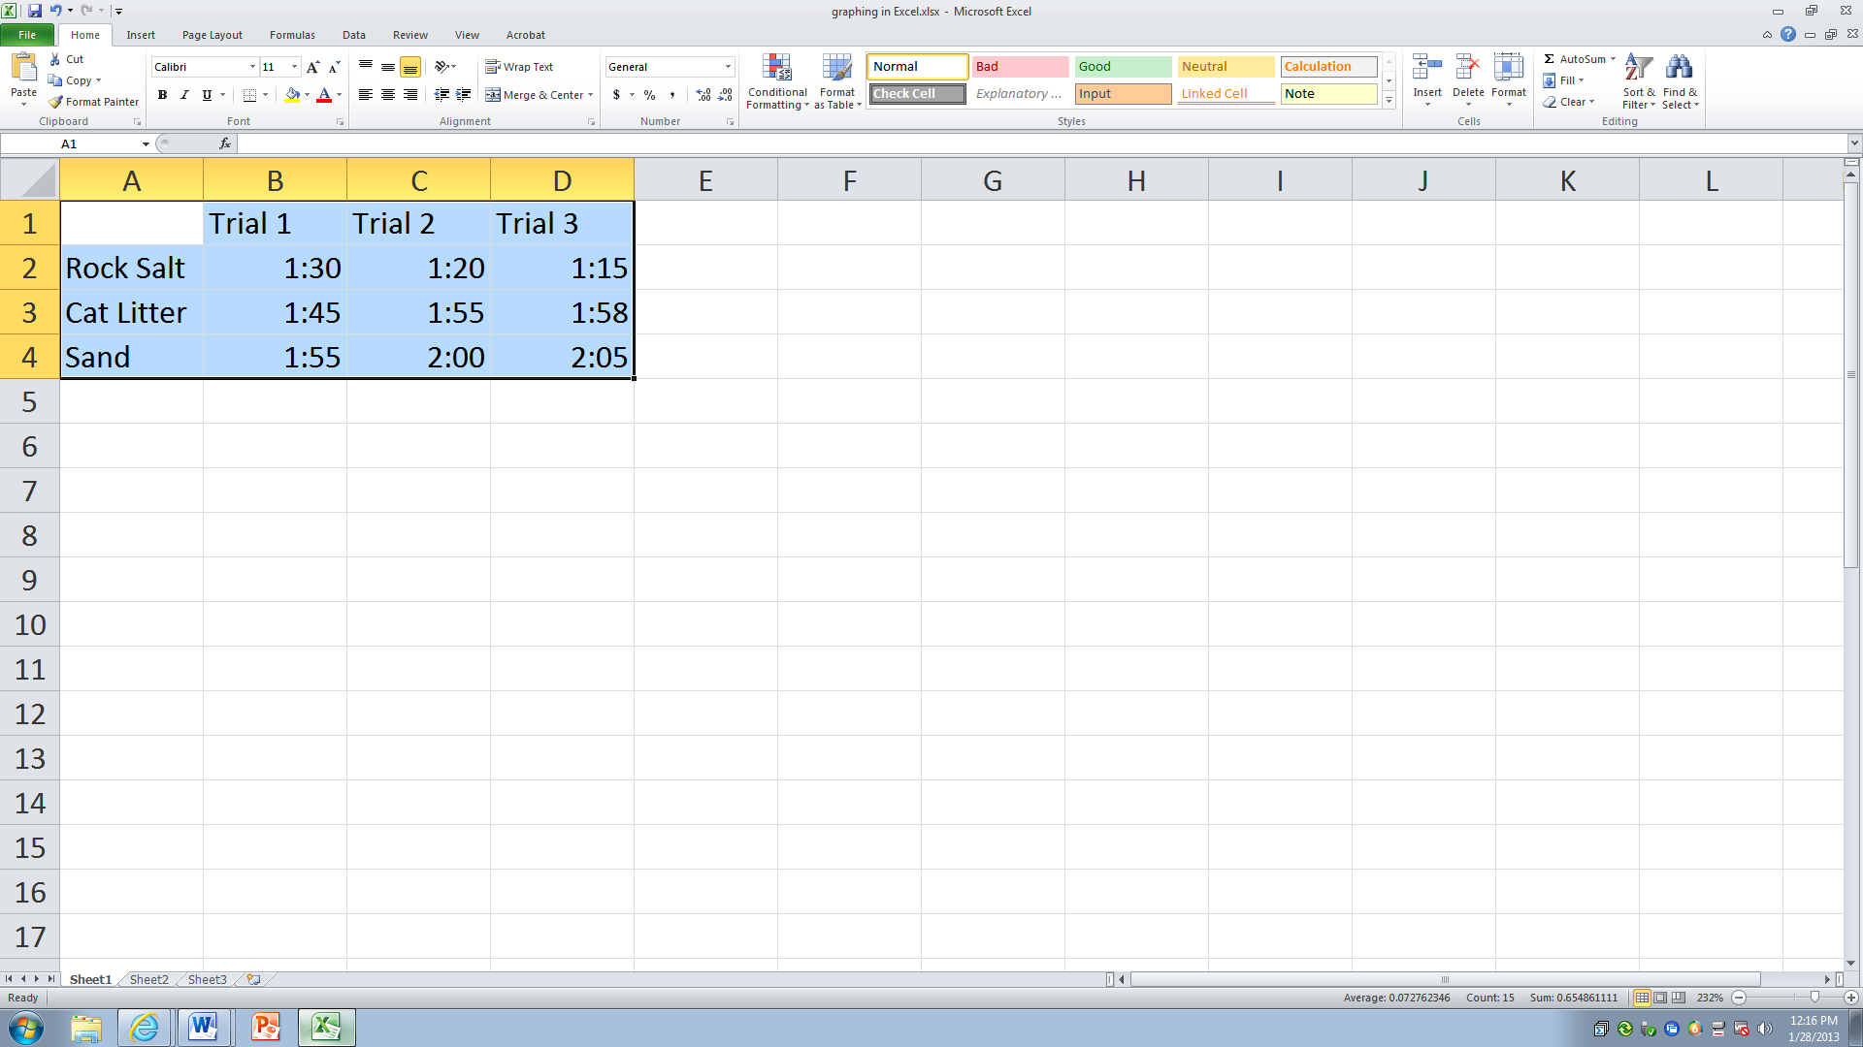

6.Next, click” Insert”, and choose “Column” under the Chart menu. Now, you can choose the kind of Column Chart that you would like.
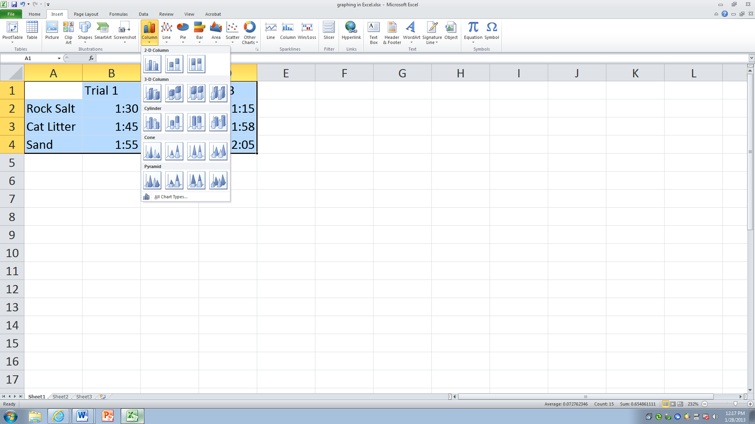
7.Once you choose your chart, your graph should appear.
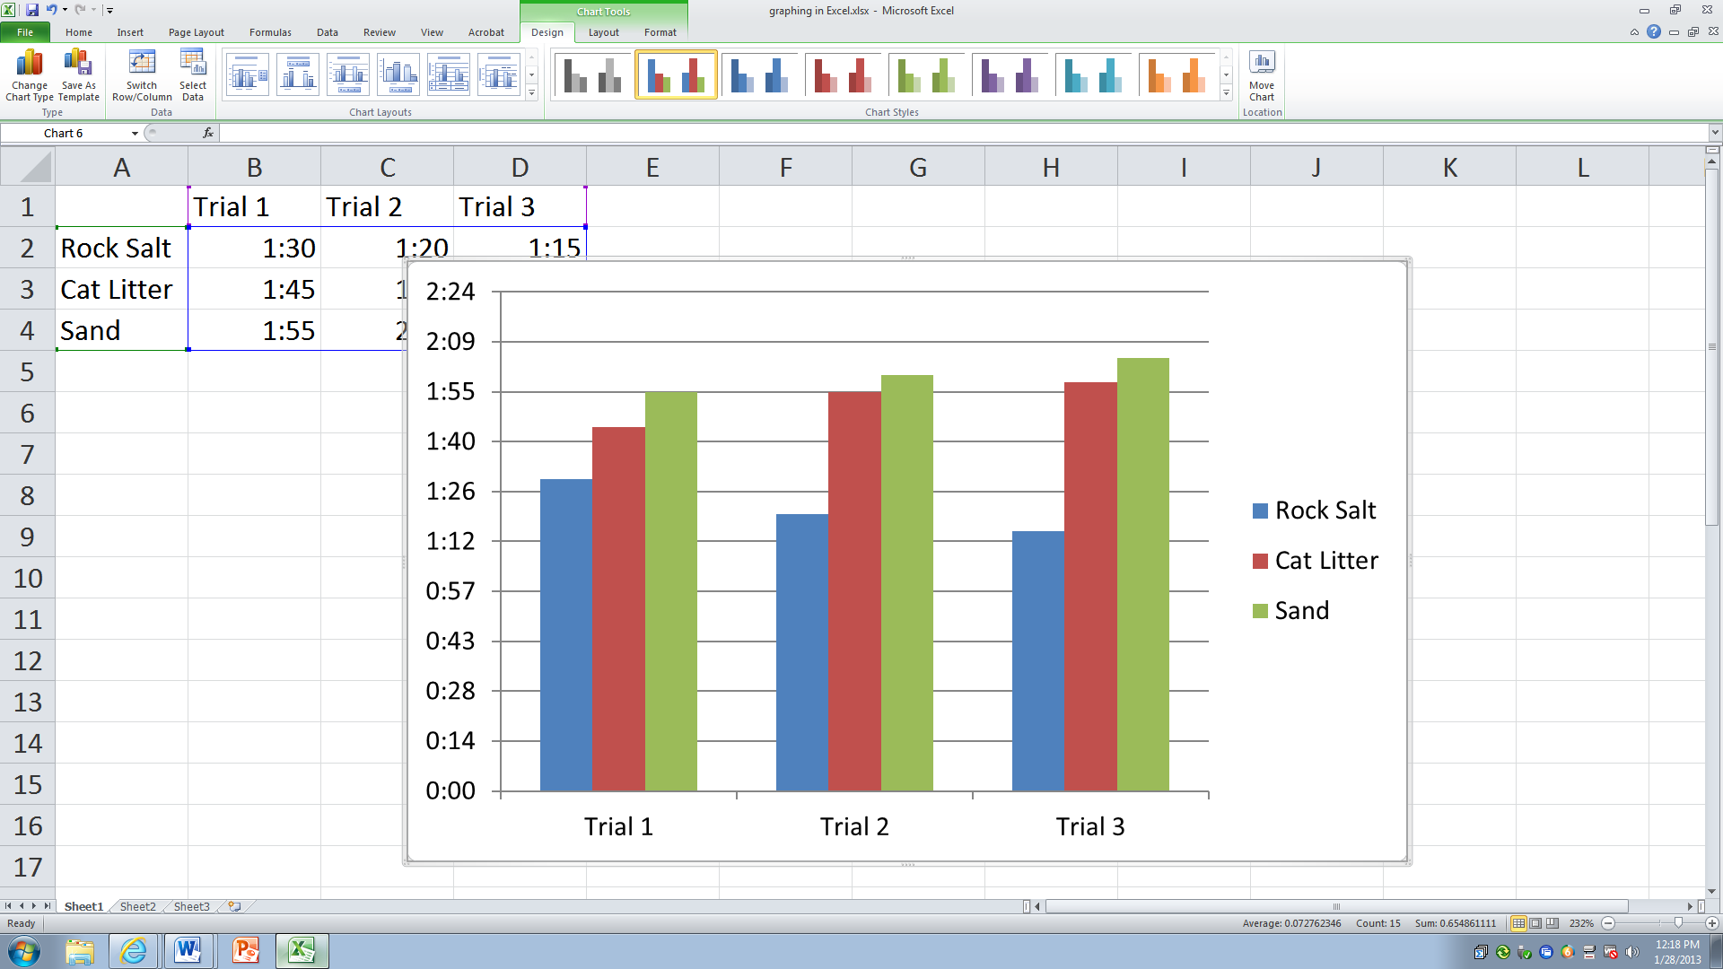
8.Now you can edit the chart.

9.To add a title click on Layout under the Chart Tools category (it should be highlighted in green)
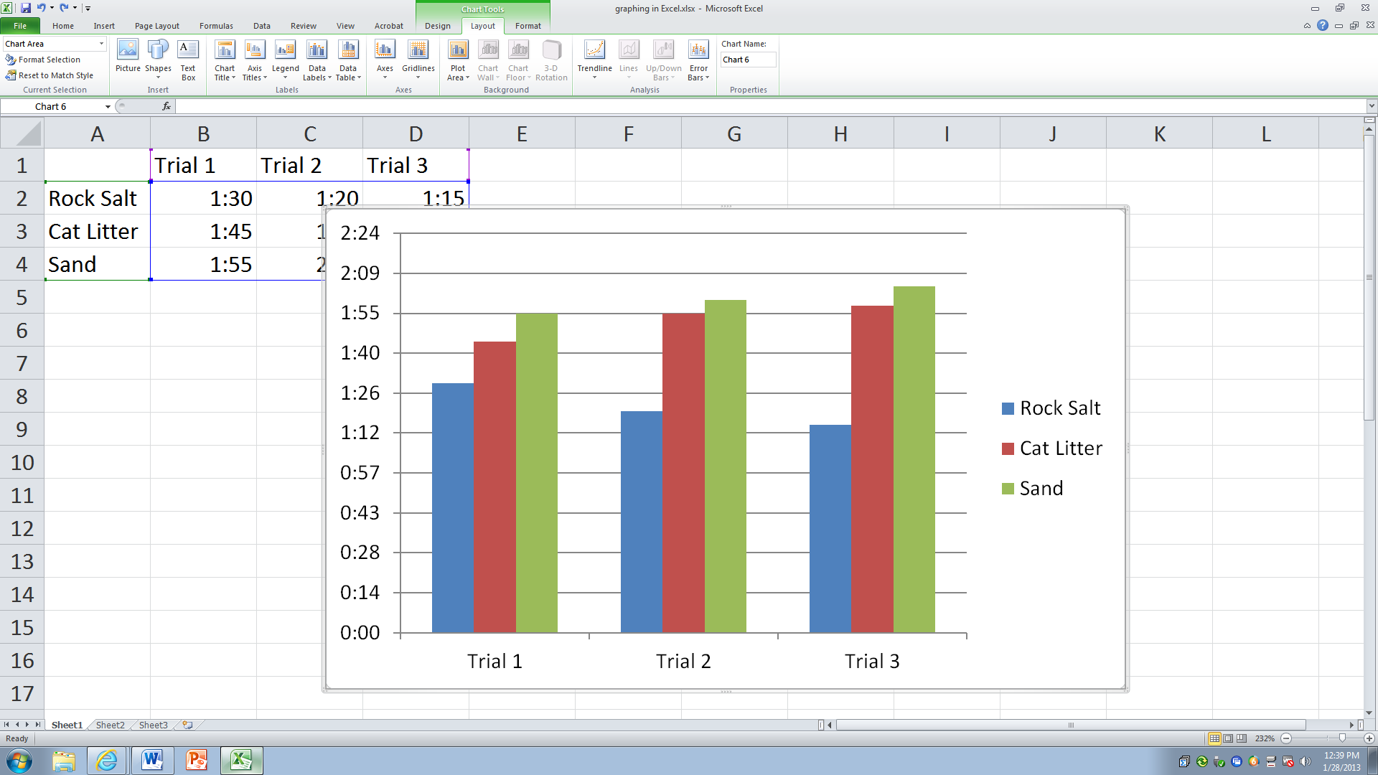
10.Now click on Chart Title and choose where you would like your title.
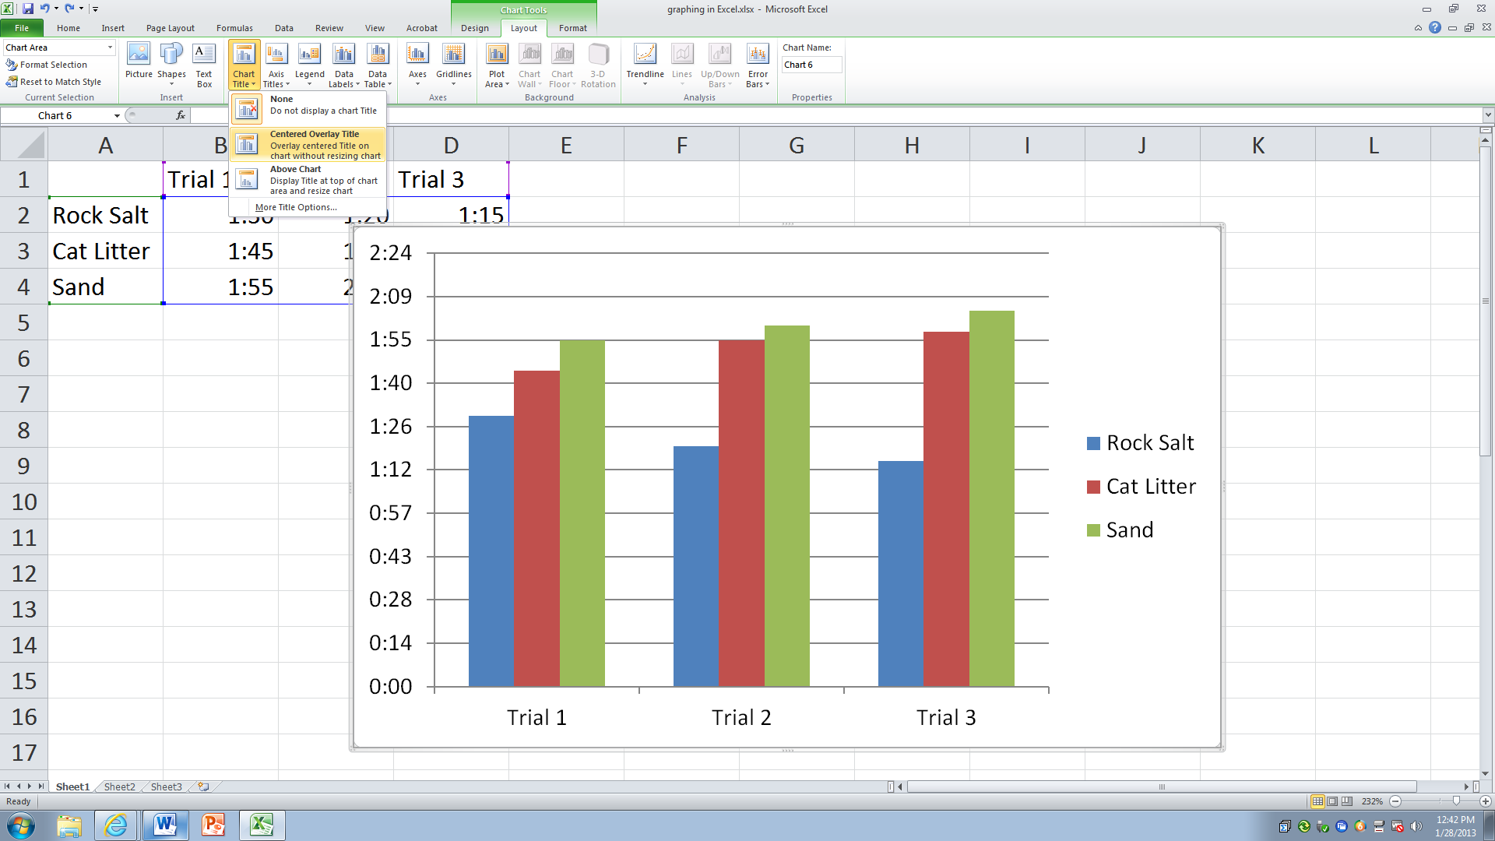
11.You may then type the title of your chart.
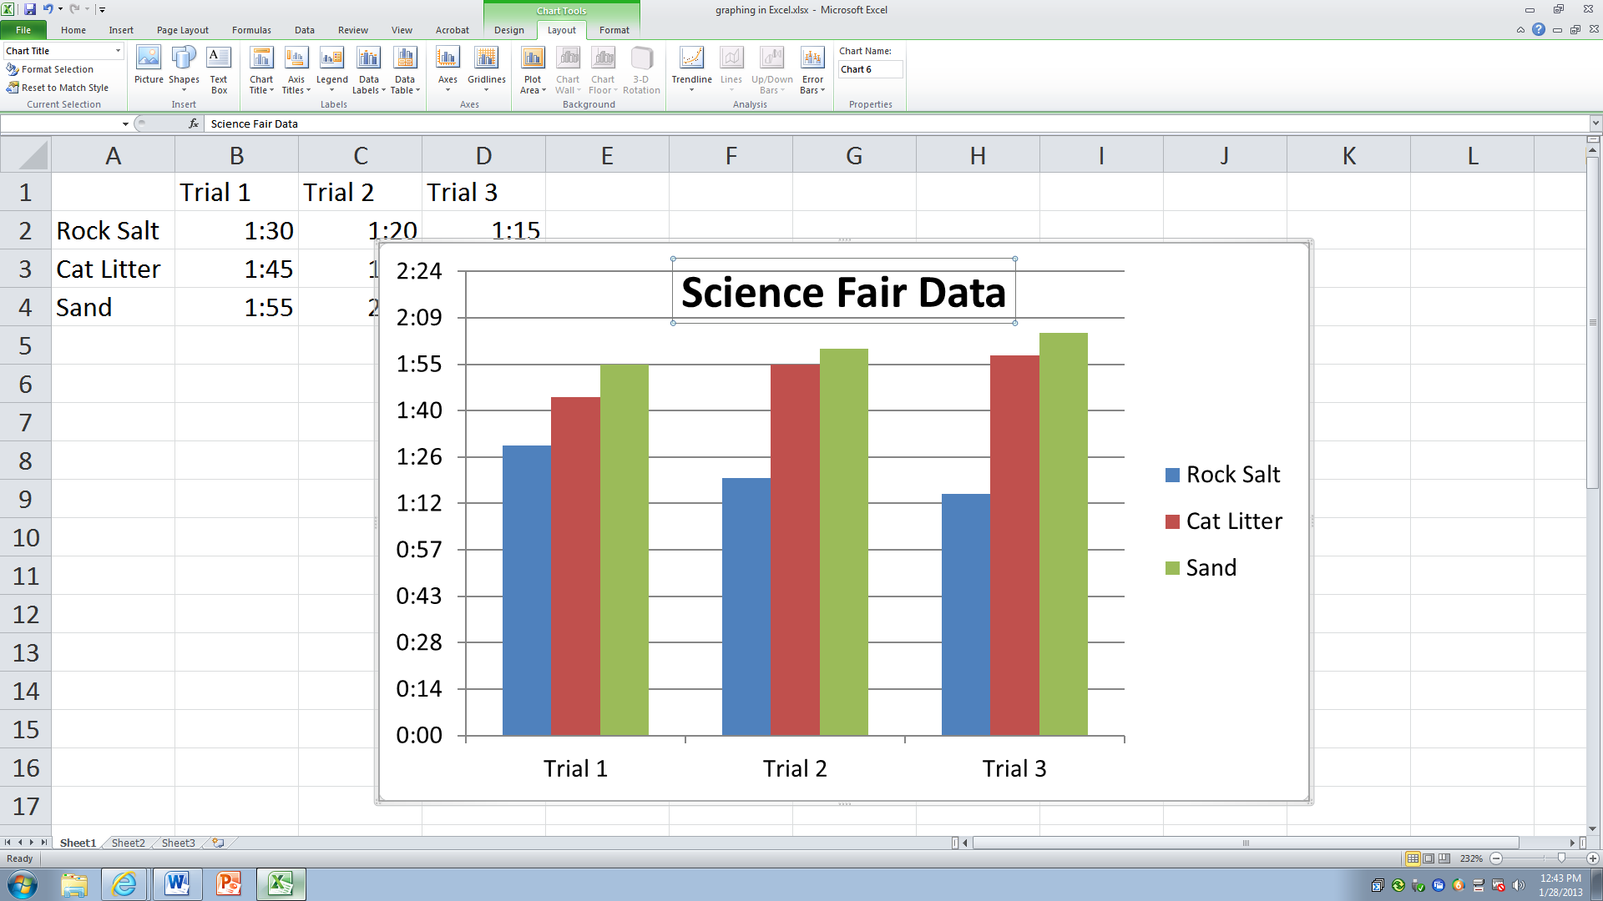
12.To insert a title for the vertical axis, click on Axis Titles and choose Primary Vertical Axis Title. Now you may choose how you want the title to look. Next, type the title that you would like to appear.
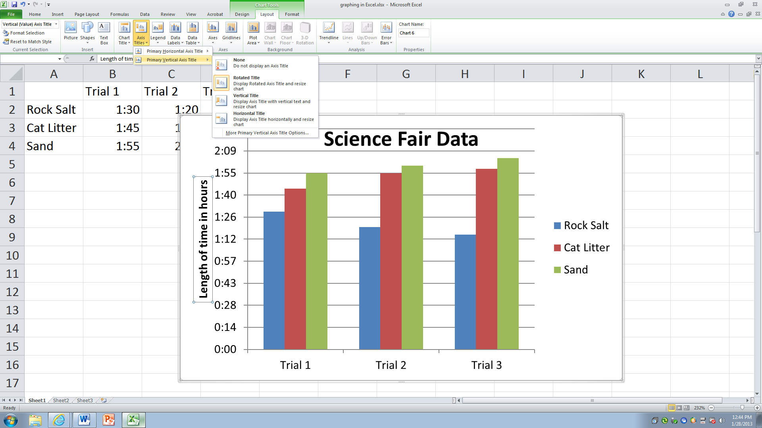
13. Be sure and save your Excel document under your number.

Great job! You are ready to make a graph for your Science Fair Project.

